Let It Be

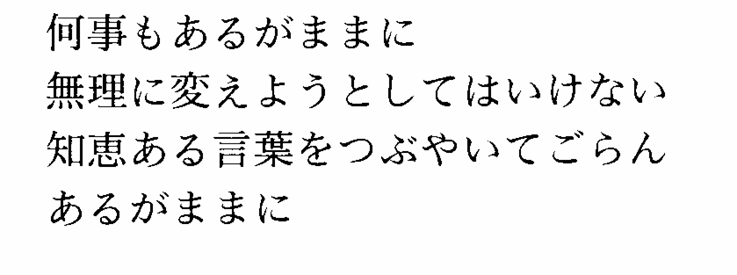
Note: This translates “Mother Mary” as 聖母のマリア. But
McCartney’s mother was named “Mary” and she died when he

was a child. It may also be about her…

